**PRACTICAL FILE**

**WEB DEVELOPMENT LAB**

**(7CS7A)**



Student Name : Sarvagya Mangal

Uni. Roll No. : 16EGJCS170

Section : C

Branch : Computer Science

Year (B.Tech.) : 4th Year/7th SEM.

**Global Institute of Technology, Jaipur**

Department of Computer Science & Engineering

(Rajasthan Technical University, KOTA)

2019-2020

**LAB Evaluation**

|  |  |  |  |  |  |  |  |  |
| --- | --- | --- | --- | --- | --- | --- | --- | --- |
| Name of Experiment | Presence in the practical | Date | Conduction of Experiment | Writing of Experiment Practical Copy | Checking of Practical copy | Via VA | Total Marks | Faculty Signature |
| Marks | (1) |  | (3) | (2) | (1) | (3) | (10) |  |
| Expt. 1 |  |  |  |  |  |  |  |  |
| Expt. 2 |  |  |  |  |  |  |  |  |
| Expt. 3 |  |  |  |  |  |  |  |  |
| Expt. 4 |  |  |  |  |  |  |  |  |
| Expt.5 |  |  |  |  |  |  |  |  |
| Expt. 6 |  |  |  |  |  |  |  |  |
| Expt. 7 |  |  |  |  |  |  |  |  |
| Expt. 8 |  |  |  |  |  |  |  |  |
| Expt. 9 |  |  |  |  |  |  |  |  |
| Expt. 10 |  |  |  |  |  |  |  |  |
| Expt. 11 |  |  |  |  |  |  |  |  |
| Expt. 12 |  |  |  |  |  |  |  |  |
| Expt. 13 |  |  |  |  |  |  |  |  |
| Expt. 14 |  |  |  |  |  |  |  |  |
| Total Sessional Scored by the Student |  |  |  |  |  |  |  |  |

List of Experiments

|  |  |
| --- | --- |
| **S. No.** | **Experiments to be Conducted** |
|
| Exp:- 1 |  |
| Exp:- 2 |  |
| Exp:- 3 |  |
| Exp:- 4 |  |
| Exp:- 5 |  |
| Exp:- 6 |  |
| Exp:- 7 |  |
| Exp:- 8 |  |
| Exp:- 9 |  |
| Exp:-10 |  |
|  |  |
|  |  |

**COURSE OBJECTIVES CONTRIBUTION TO PROGRAM OUTCOMES**

|  |  |
| --- | --- |
| **COURSE OBJECTIVE** | **PROGRAM OUTCOME** |
| 1) Apply the knowledge to manage and to handle web site design and development to solve the real world problems.  2) Gain a reputed designation as good web designer and web developer ethically by applying advance web technologies.  3) Be successfully accepted in future’s development scenario as an engineering graduate pursuit of lifelong learning.  4) Exhibit team spirit management & effective communication dealings. | a) Graduates will demonstrate an ability to  identify formulate and solve the web based  problems.   1. Ability to apply conceptual skills of web site design and development. 2. Graduate can participate and succeed in   Competitive examinations like GATE etc.   1. Graduate will show the understanding of impact of Computer engineering solutions on the society and also be aware of contemporary issues. |

**Course Outcomes (student learning outcomes)**

Graduate of the program will:

1. Demonstrate an understanding of Web Development Lab.
2. They are able to understand the difference among the various scripting languages.
3. Demonstrate proficiency in using web site design and development according to market demand.
4. Can show their ability to apply conceptual skills of Web Site Design and Development.
5. Graduates will show interest towards the development of different modern and efficient tool.
6. Graduates will able to know about the HTML, CSS, VB Script, Java Script, Apache Web Server, Internet Information Server, Active X Controls, JSP, ASP, Java Servlets, PHP, Ajax Programming, Web Services

Experiment 1

**Q. 1 What is HTML. Explain popular tags used in web page designing.**

Ans. - HTML is a computer language devised to allow website creation. These websites can then be viewed by anyone else connected to the Internet. It is relatively **easy to learn**, with the basics being accessible to most people in one sitting; and quite **powerful** in what it allows you to create.The definition of HTML is **HyperText Markup Language**.

* HyperText is the method by which you move around on the web — by clicking on special text called **hyperlinks** which bring you to the next page.
* Markup is what **HTML tags** do to the text inside them. They mark it as a certain type of text.

**Popular Tags:**

* <a> for link
* <b> to make bold text
  + <strong> for bold text with emphasys
* <body> main HTML part
* <br> for break
* <div> it is a division or part of an HTML document
* <h1>... for titles
* <i> to make an italic text
* <img> for images in document
* <ol> is an ordered list, <ul> for an unordered list
  + <li> is a list item in bulleted (ordered list)
* <p> for paragraph
* <span> to style part of text

**Q. 2 Differentiate Client side scripting and server side scripting with the help of example.**

Ans. –

|  |  |
| --- | --- |
| **Server side scripting** | **Client side scripting** |
| Server side scripting is used to create dynamic pages based a number of conditions when the users browser makes a request to the server. | Client side scripting is used when the users browser already has all the code and the page is altered on the basis of the users input. |
| The Web Server executes the server side scripting that produces the page to be sent to the browser. | The Web Browser executes the client side scripting that resides at the user’s computer. |
| Server executes server-side scripts to send out a page but it does not execute client-side scripts. | The browser receives the page sent by the server and executes the client-side scripts. |
| Server side scripting can access the file system residing at the web server. | Client side scripting can’t access the file system that resides at the web server. |
| Server side scripting can’t be blocked by the user. | Client side scripting is possible to be blocked by the user. |
| Examples of Server side scripting languages: PHP, JSP,  ASP, ASP.Net, Ruby, Perl n many more. | Examples of Client side scripting languages: Javascript, VB script, etc. |

**Q. 3 Explain the procedure to design HTML pages (e.g. Editors, Browsers, page format)**

Ans. – Step 1: Open your text editor (eg Notepad,Notepad++,etc.)

Step 2: Write your HTML skeleton.

Step 3: Save your file with .html extension

Step 4 :Open the webpage in your web browser (eg Chrome,Mozilla,etc.)

**Q. 4 Assignment 1 – It has 3 tasks, you have to write the code and output snapshot after each task.**

**Note – Your screenshot should have date and time of your system.**

**Task 1 – Design the below page with the help of HTML. (Sample output)**

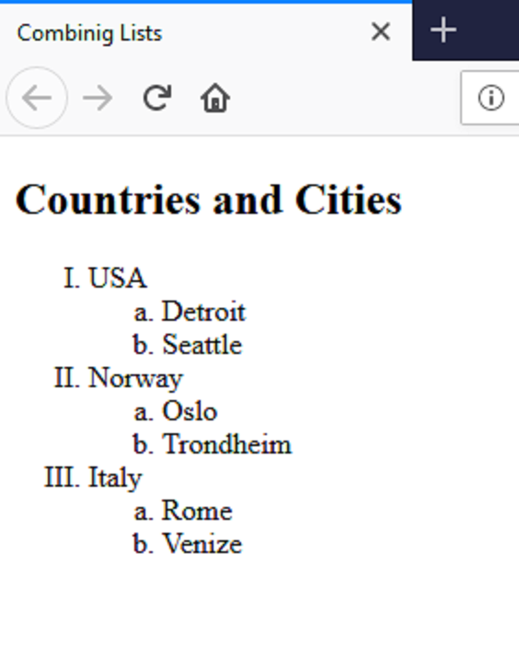

**Sol. -** 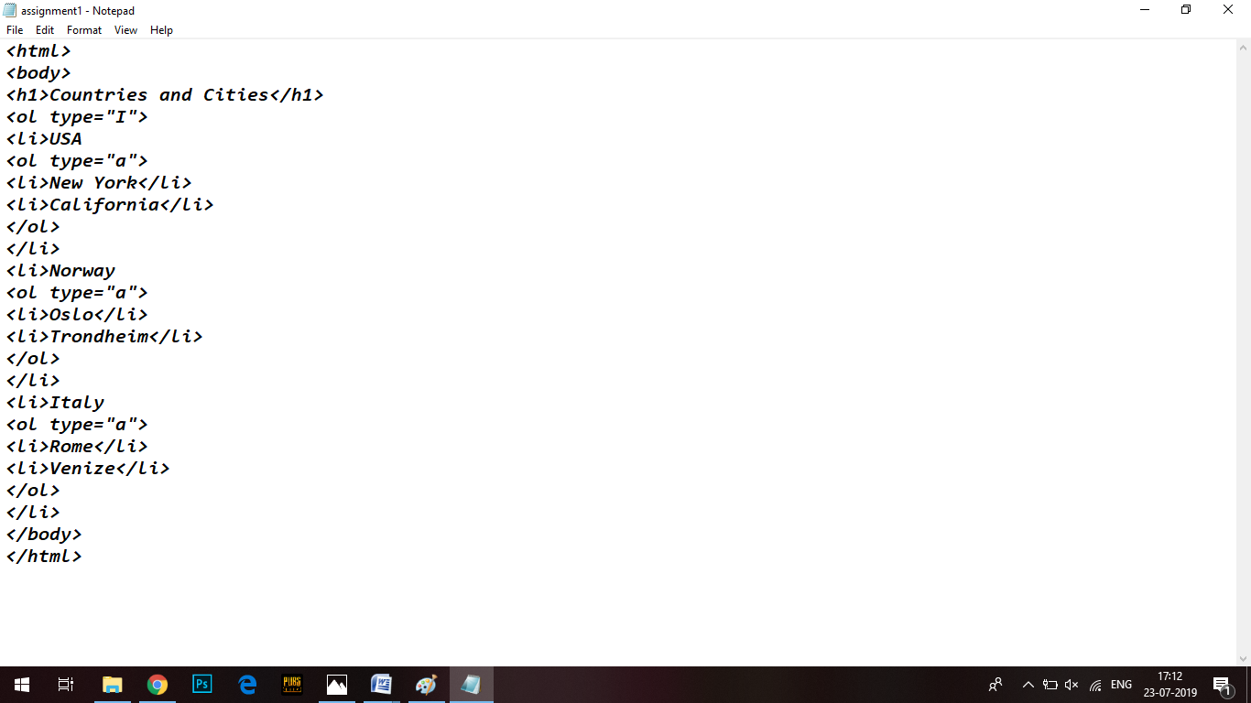

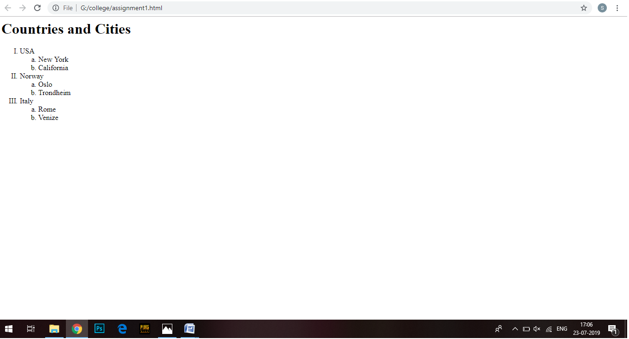

**Task 2 Design the below page with the help of HTML. Create Page1, Page2, Page3 to link below page. Add relevant information to the pages.**

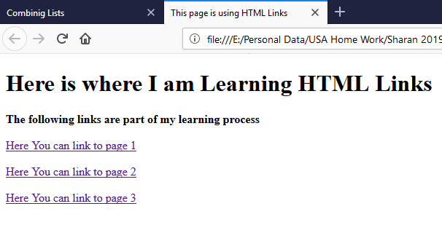

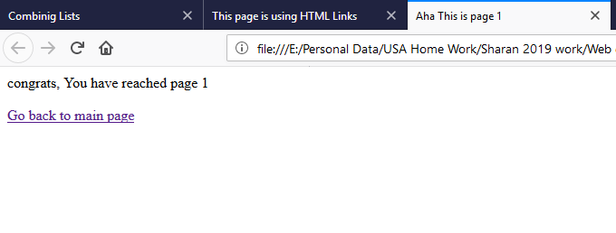

**Sol. –**

**<**html>

<body>

<h1>Here is where I am Learning HTML Links</h1>

<h3>The following links are part of my leaning process</h3>

<p><a href="page1.html">Here You can link to page 1</a></p>

<p><a href="page2.html">Here You can link to page 2</a></p>

<p><a href="page 3.html">Here You can link to page 3</a></p>

</body>

</html>

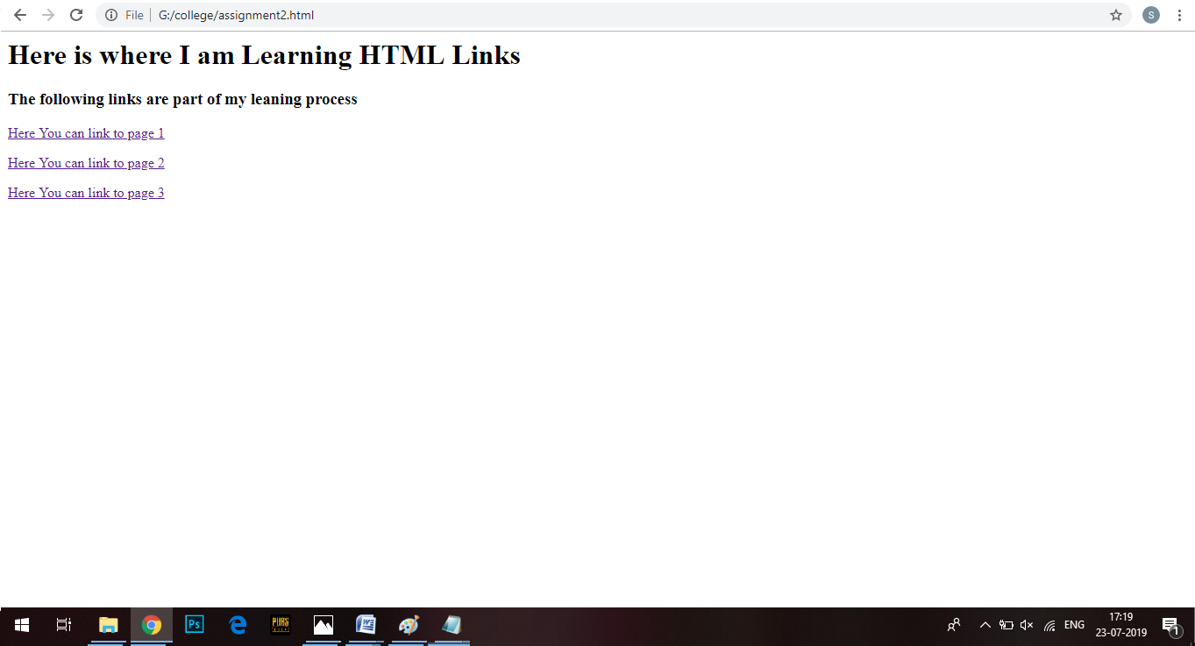

<html>

<body>

<h3>This is page 1</h3>

<p><a href="assignment2.html">GO back to main page</a></p>

</body>

</html>

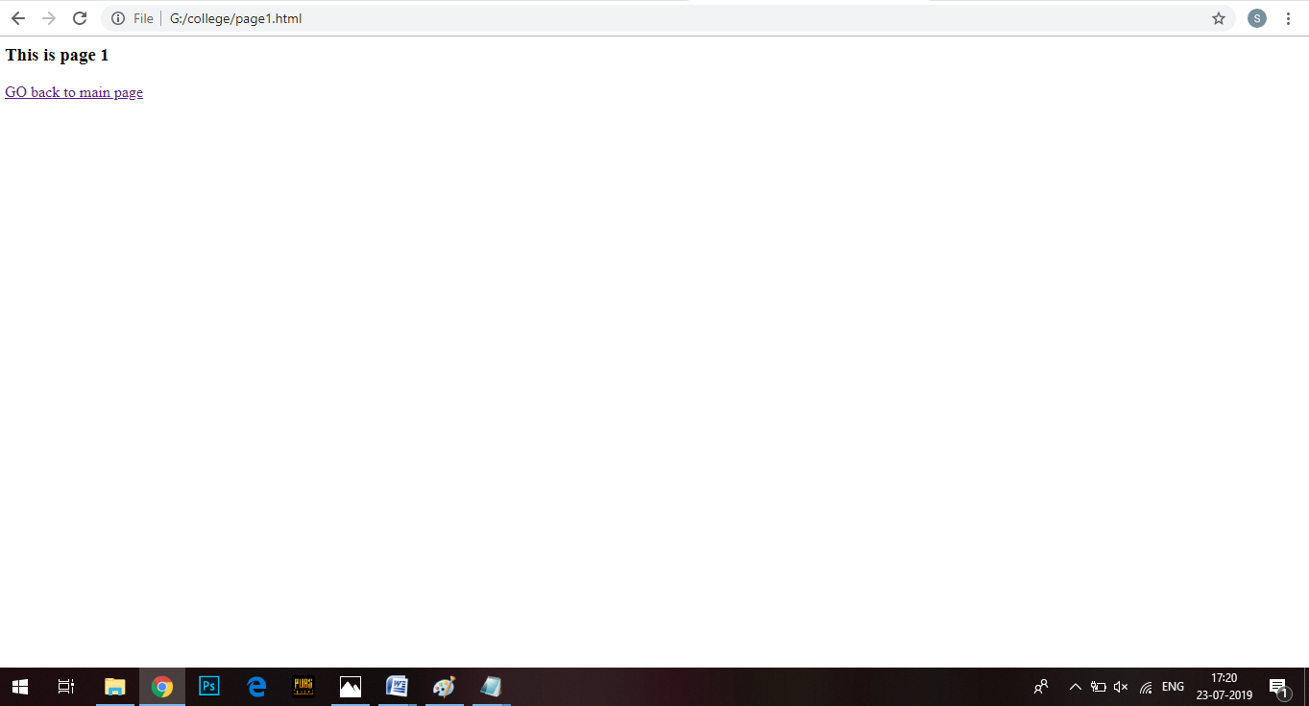

<html>

<body>

<h3>This is page 2</h3>

<p><a href="assignment2.html">GO back to main page</a></p>

</body>

</html>

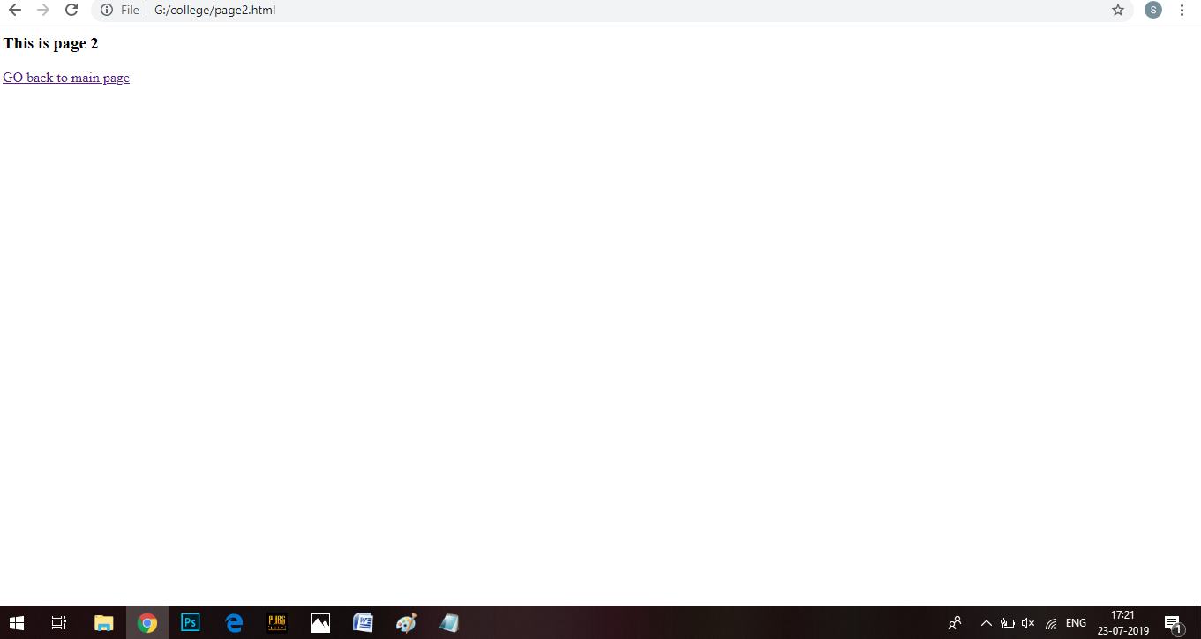

<html>

<body>

<h3>This is page 3</h3>

<p><a href="assignment2.html">GO back to main page</a></p>

</body>

</html>

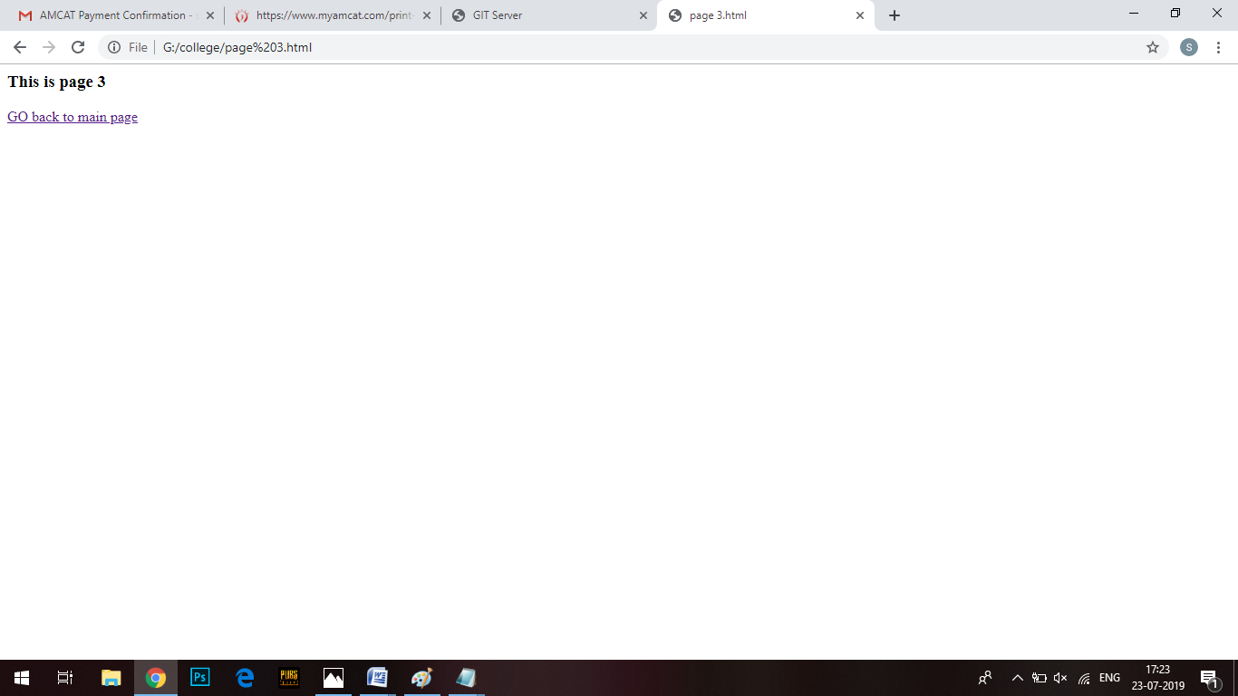

**Task 3 – Create a webpage in HTML with the help of following instructions**

1. A title for the browser
2. A title for your web page
3. 5 HTML paragraphs with relevant information about your web page.
4. A heading for each paragraph
5. An unordered list of 3 items in the first paragraph
6. An ordered list of 3 items in the third paragraph. All the text should be in italics
7. Go back to step 4 and add another list item which will be a link. Create a link with the text **Here's the link to my favourite website**. Make sure that the link directs users to **your favourite website**
8. After Paragraphs 5, insert an image of your choice and make it hyperlink (clickable) to relevant website.
9. At the end of the main body text, use the appropriate character entity to include a copyright symbol with your name, roll no., branch and year.

**Sol.**

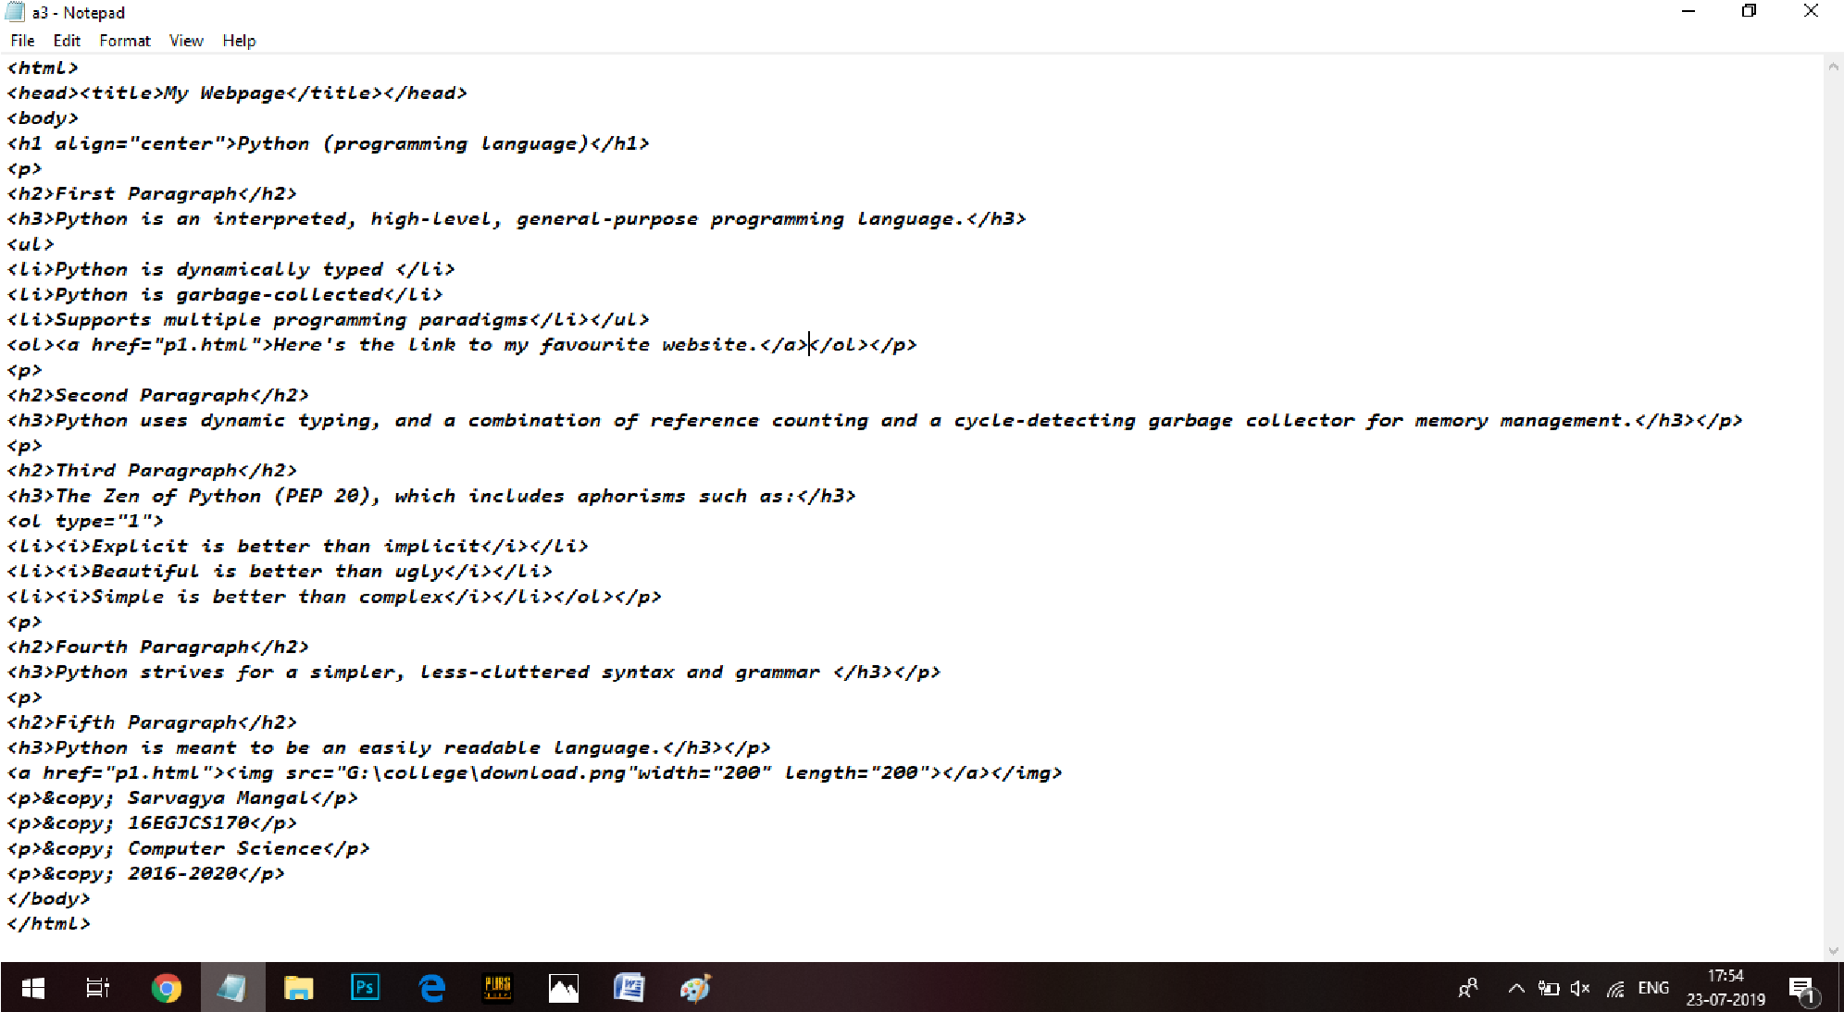

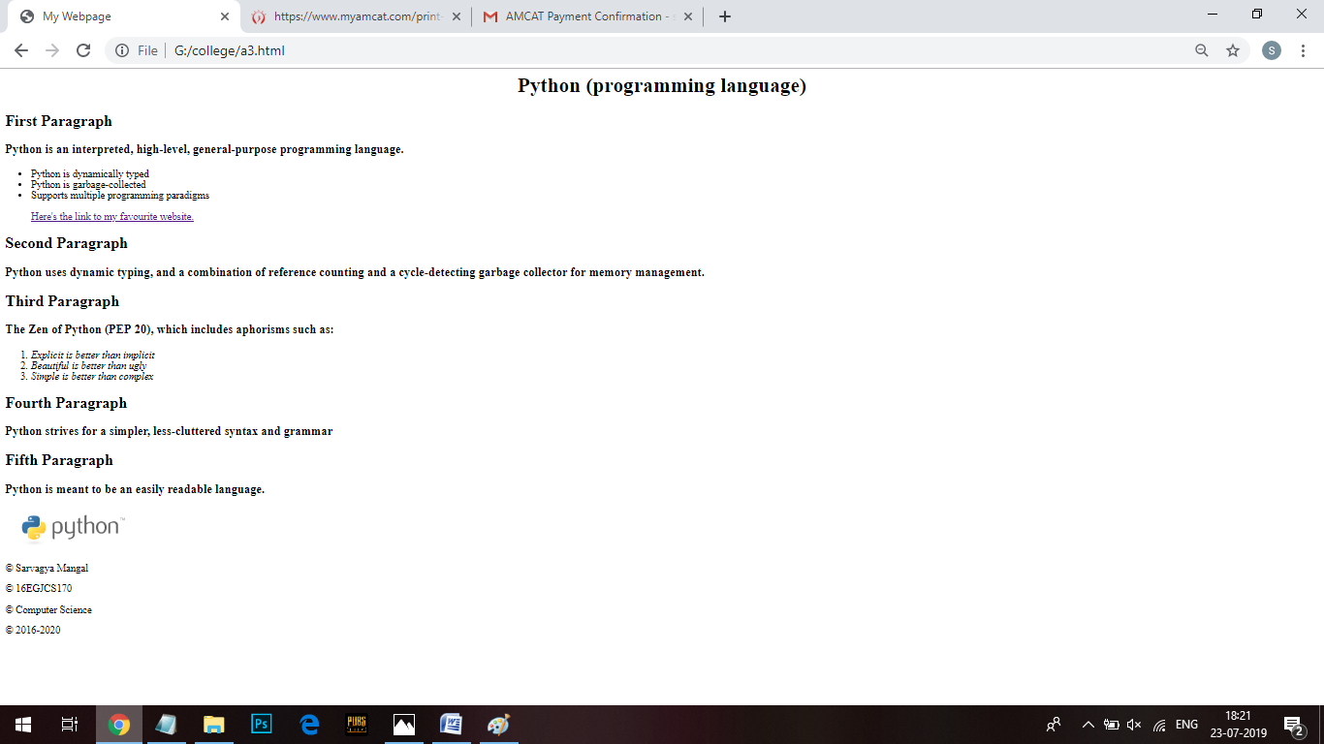

Experiment 2

**Assignment 1 - Create the following structure of tables and form with the help of HTML. Write the solution code and output snapshot of the following task.**

**Task 1**

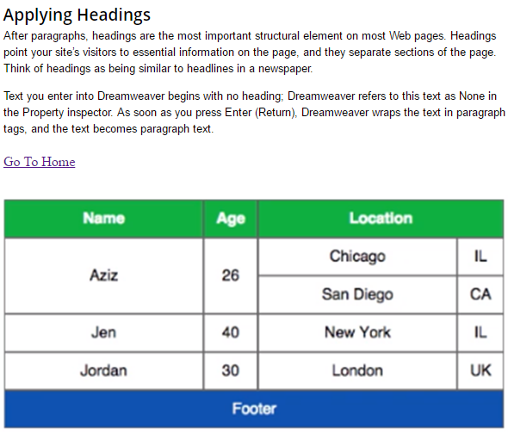

**Sol -**

<html>

<head>

<style>

table, th, td {

border: 1px solid black;

border-collapse: collapse;

}

th, td {

padding: 15px;

text-align: center;

}

</style>

</head>

<body>

<table style="width:80%" align="center">

<tr bgcolor="green"><th width="18%">Name</th>

<th width="5%">Age</th>

<th colspan="2" width="18%">Location</th></tr>

<tr><td rowspan="2">Aziz</td>

<td rowspan="2">26</td>

<td>Chicago</td>

<td width="5%">IL</td></tr>

<tr><td>San Diego</td>

<td width="5%">CA</td></tr>

<tr><td >Jen</td>

<td >40</td>

<td>New York</td>

<td width="5%">IL</td></tr>

<tr><td >Jordan</td>

<td >30</td>

<td>London</td>

<td width="5%">UK</td></tr>

<tr bgcolor="blue">

<td colspan="4">Footer</td></tr>

</body>

</html>

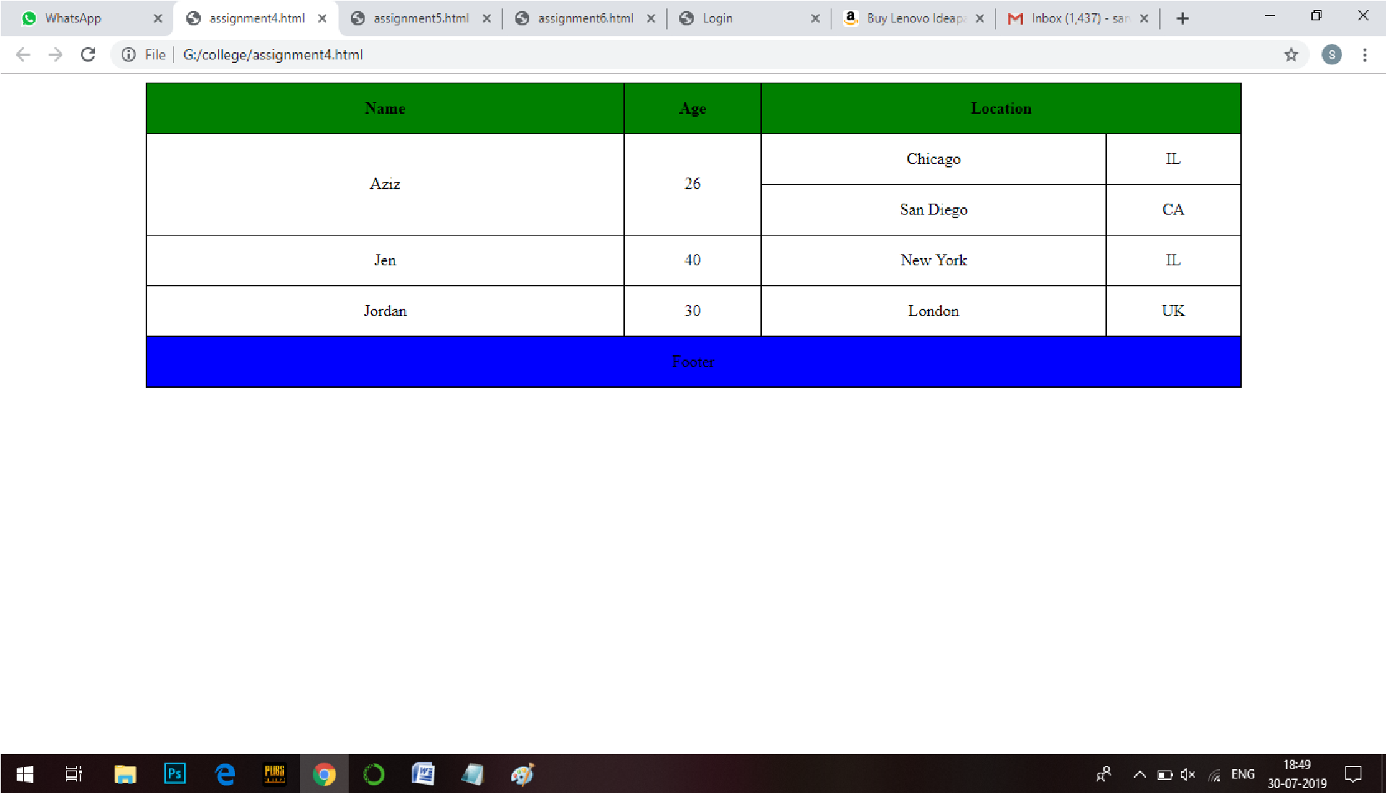

**Task 2**

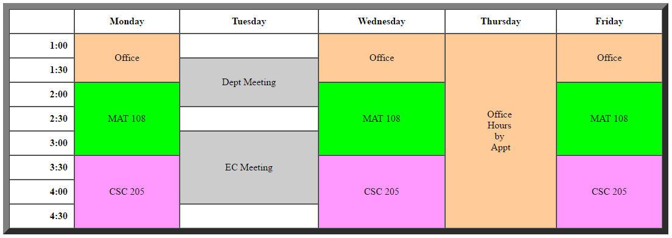

**Sol –**

<html>

<body>

<table style="width:80%" align="center" border="5" cellspacing="0" cellpadding="0" height="50" >

<tr align="center" height="35"><th width="8%"></th>

<th width="16%">Monday</th>

<th width="16%">Tuesday</th>

<th width="16%">Wednesday</th>

<th width="16%">Thursday</th>

<th width="16%">Friday</th></tr>

<tr align="center" height="50"><td>1:00</td>

<td rowspan="2" bgcolor="FFCC99">Office</td>

<td></td>

<td rowspan="2" bgcolor="FFCC99">Office</td>

<td rowspan="8" bgcolor="FFCC99"><br>Office</br><br>Hours</br><br>by</br><br>Appt</br></td>

<td rowspan="2" bgcolor="FFCC99">Office</td></tr>

<tr align="center" height="50"><td>1:30</td>

<td rowspan="2" bgcolor="CCCCCC">Dept Meeting</td></tr>

<tr align="center" height="50"><td>2:00</td>

<td rowspan="3" bgcolor="#7cfc00">MAT 108</td>

<td rowspan="3" bgcolor="#7cfc00">MAT 108</td>

<td rowspan="3" bgcolor="#7cfc00">MAT 108</td></tr>

<tr align="center" height="50"><td>2:30</td></tr>

<tr align="center" height="50"><td>3:00</td>

<td rowspan="3" bgcolor="CCCCCC">EC Meeting</td></tr>

<tr align="center" height="50"><td>3:30</td>

<td rowspan="3" bgcolor="#ffb6c1">CSC 205</td>

<td rowspan="3" bgcolor="#ffb6c1">CSC 205</td>

<td rowspan="3" bgcolor="#ffb6c1">CSC 205</td></tr>

<tr align="center" height="50"><td>4:00</td></tr>

<tr align="center" height="50"><td>4:30</td></tr>

</body>

</html>

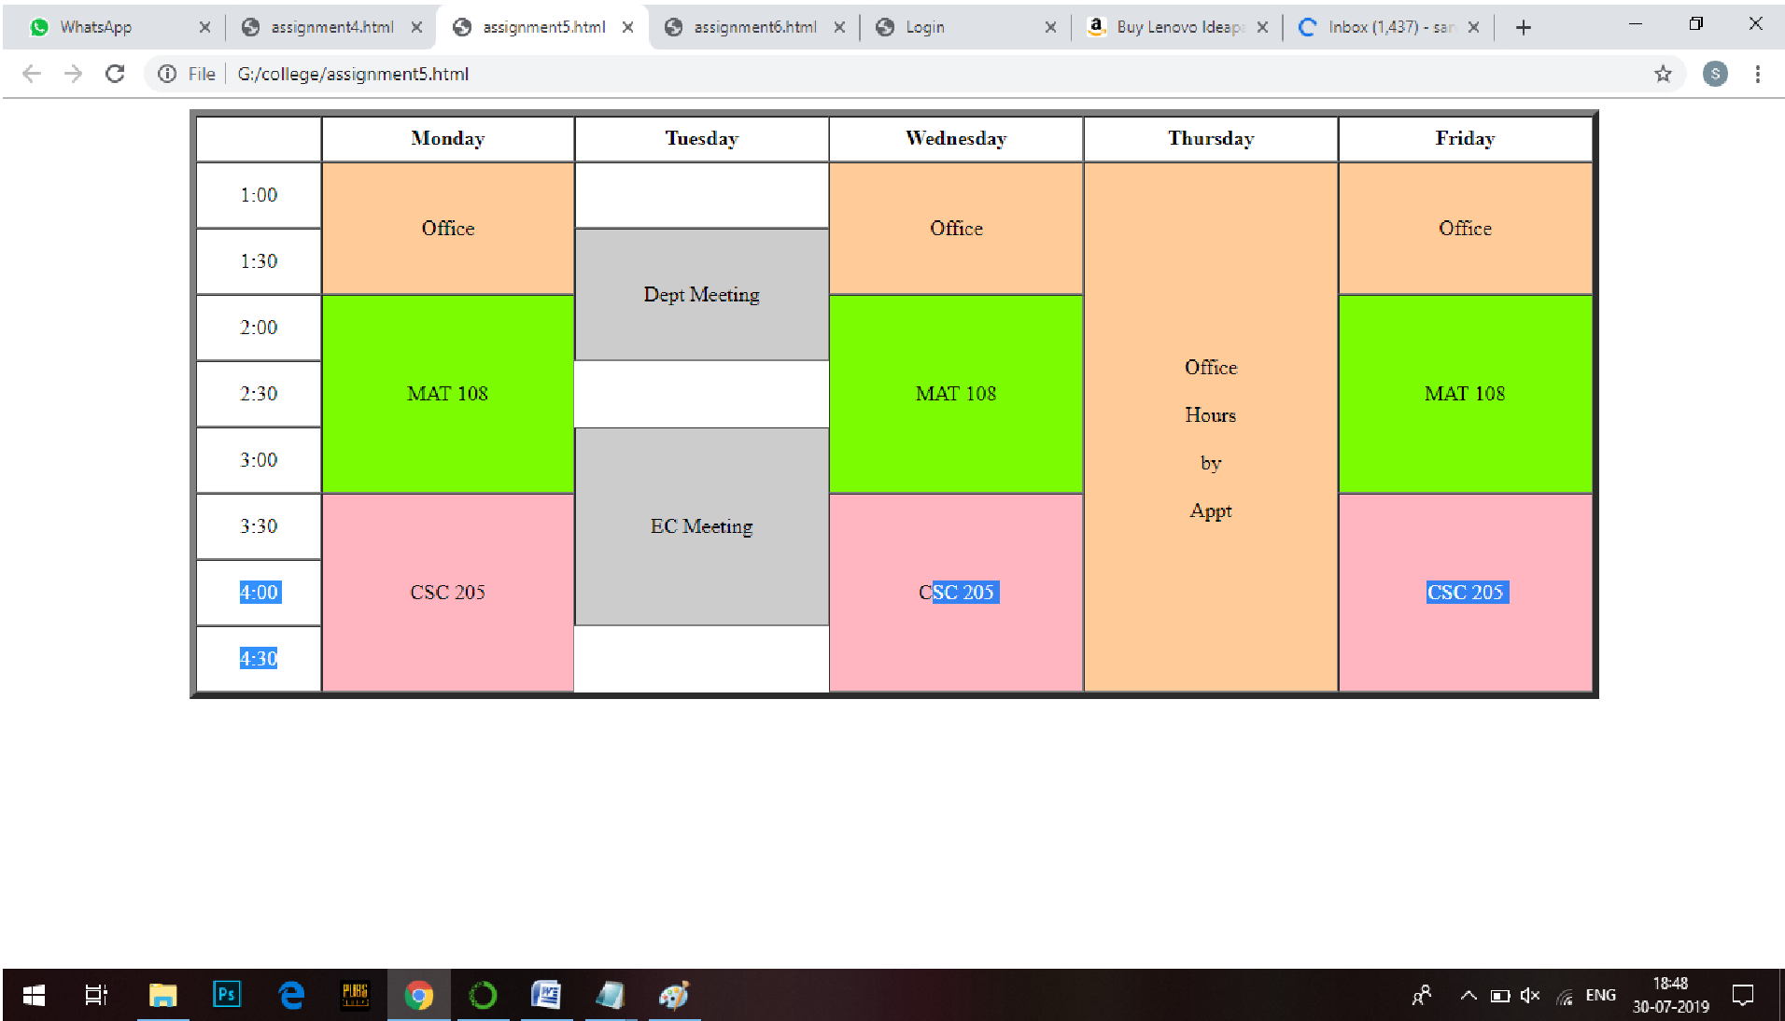

**Task 3**

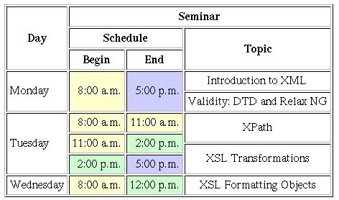

**Sol –**

<html>

<body>

<table style="width:80%" align="center" border="1">

<tr align="center"><th rowspan="3" width="8%">Day</th>

<th width="14%" colspan="3">Seminar</th></tr>

<tr align="center"><th colspan="2">Schedule</th>

<th rowspan="2">Topic</th></tr>

<tr align="center"><th>Begin</th>

<th>End</th></tr>

<tr align="center"><td rowspan="2">Monday</td>

<td rowspan="2" bgcolor="FFCC99">8:00 am</td>

<td rowspan="2" bgcolor="gray">5:00 pm</td>

<td>Introduction to XML</td></tr>

<tr align="center"><td>Validity:DTD and Relax NG</td>

<tr align="center">

<td rowspan="5">Tuesday</td>

<td rowspan="2" bgcolor="FFCC99">8:00 am</td>

<td rowspan="2" bgcolor="FFCC99">11:00 am</td>

<td rowspan="3">XPath</td></tr>

<tr></tr>

<tr align="center"><td rowspan="2" bgcolor="FFCC99">11:00 am</td>

<td rowspan="2" bgcolor="#9acd32">2:00 pm</td>

</tr>

<tr align="center"><td rowspan="2">XSL transformations</td>

</tr>

<tr align="center"><td bgcolor="#9acd32">2:00 pm</td>

<td bgcolor="gray">5:00 pm</td>

</tr>

<tr align="center">

<td>Wednesday</td>

<td bgcolor="FFCC99">8:00 am</td>

<td bgcolor="#9acd32">12:00 am</td>

<td>XSL Formatting Objects</td></tr>

</body>

</html>

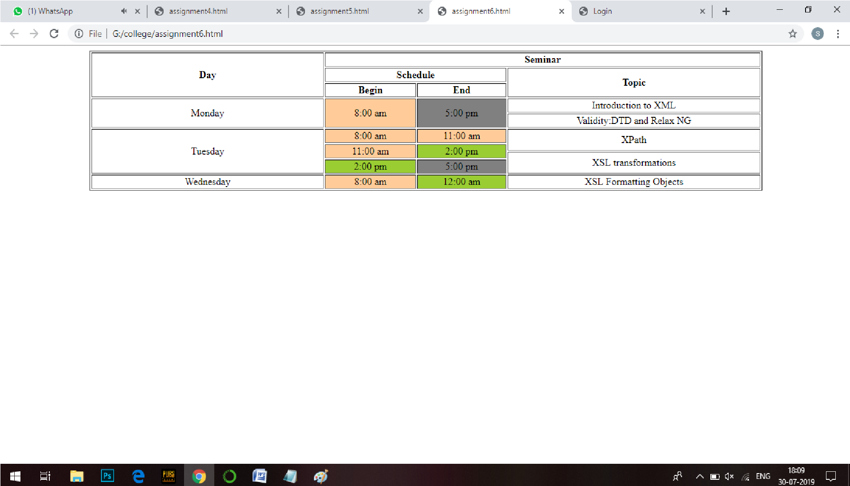

**Task 4**

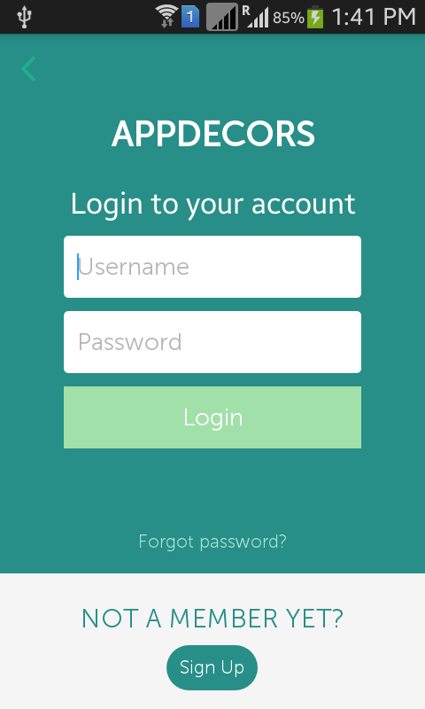

**Sol. –**

<html >

<head>

<title>Login</title>

</head>

<body>

<center>

<form style="background-color: blue; width: 50%; padding: 5px;">

<td style="font-size: 30px;"><h2>APPDECORS</h2></td><br>

<td>Login to your account</td><br>

<input type="text" placeholder="Username" style="margin-top: 1%; padding: 5px;"><br>

<input type="text" placeholder="Password" style="margin-top: 1%; padding: 5px;"><br>

<button type="button" style="margin-top: 2%; color: white; background-color: yellowgreen;">Login</button><br>

<td style="margin-top: 5%;"><h5>Forgot password?</h5></td>

<td>NOT A MEMBER YET ?</td><br>

<button type="button" style="margin-top: 2%;">SIGN UP</button>

</form>

</center>

</body>

</html>

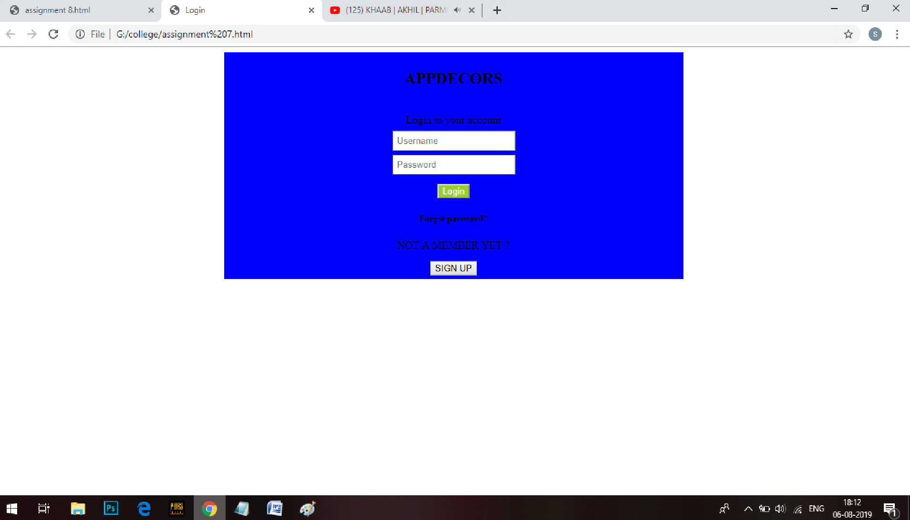

Experiment 3

**Assignment 1- Create the following registration page with the help of HTML**

**Task 1**

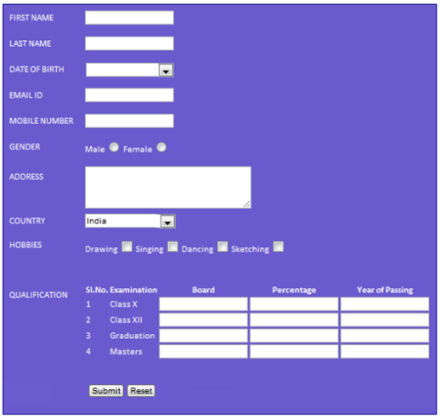

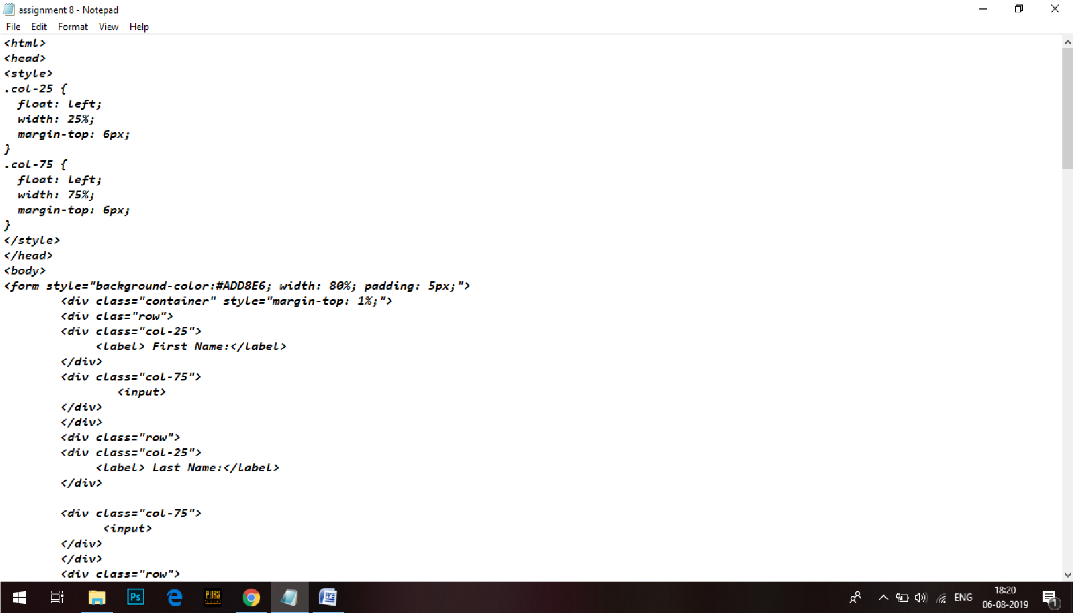

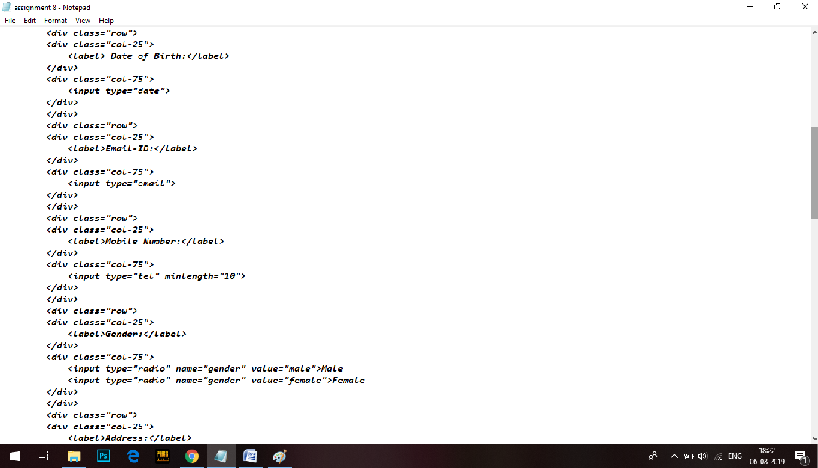

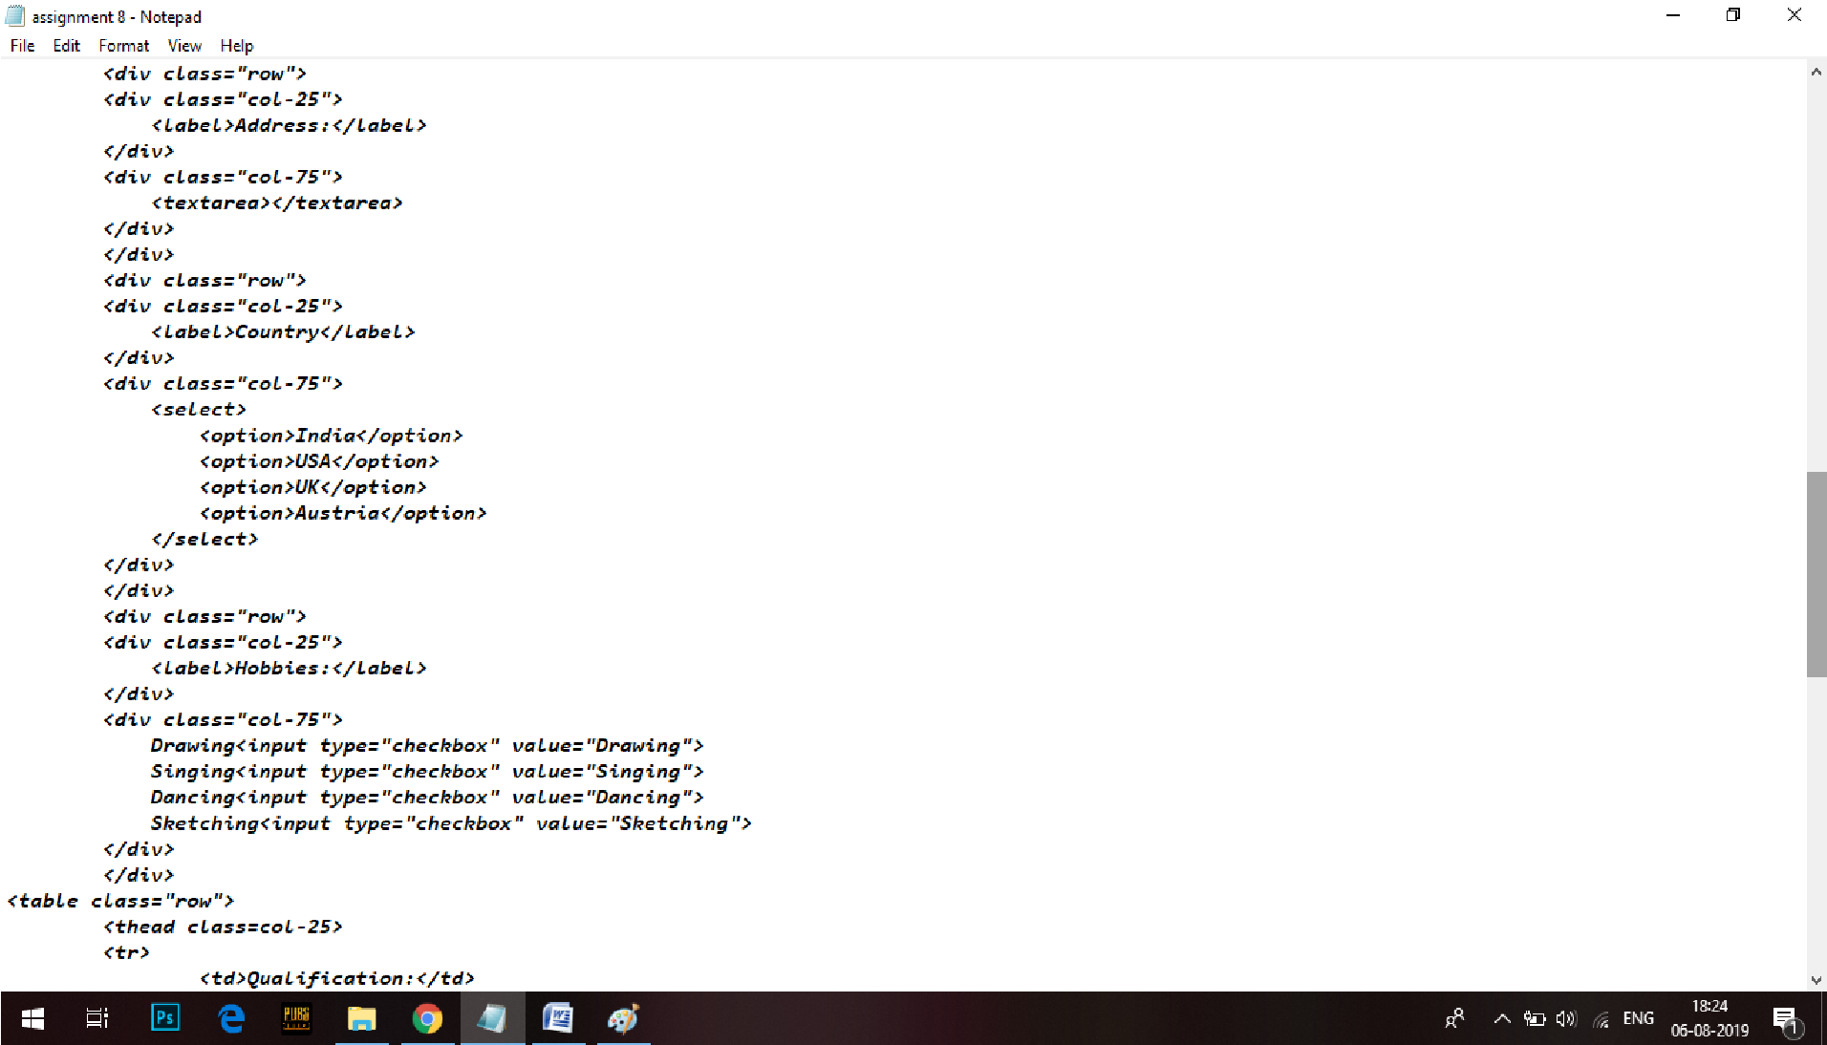

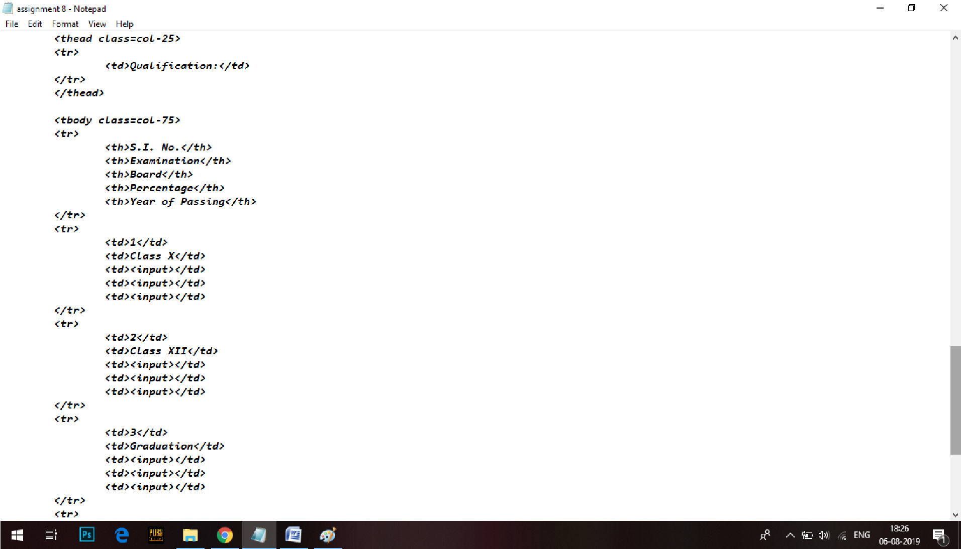

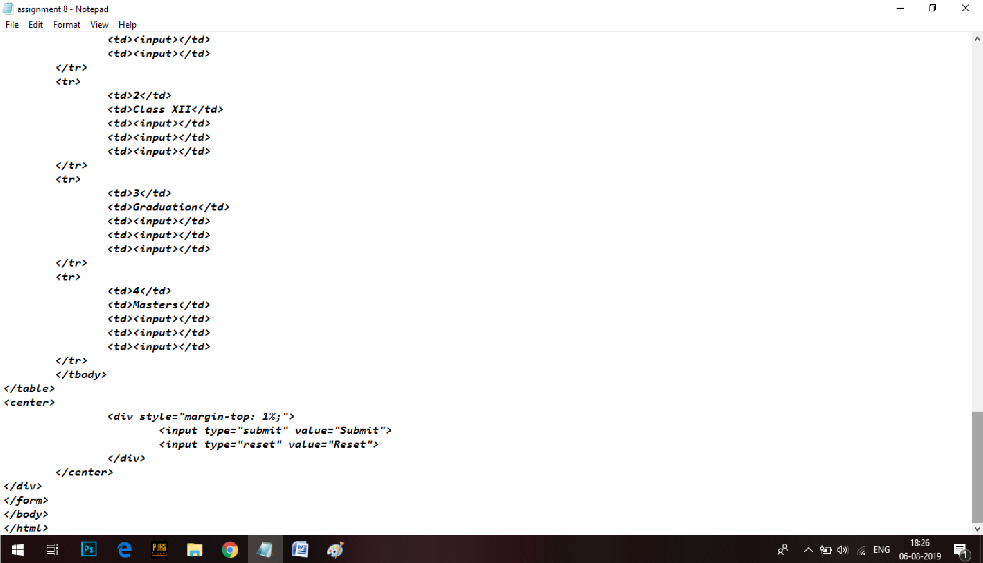

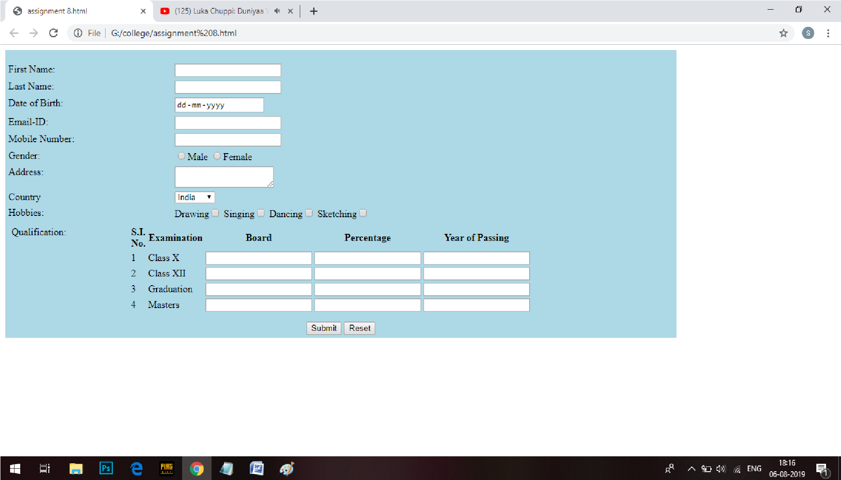

**Assignment 2 –**

**Task 1**

**What is CSS. Discuss in detail about the types of CSS.**

CSS stands for Cascading Style Sheets. CSS describes how HTML elements are to be displayed. It is a style sheet language which is used to describe the look and formatting of a document written in markup language. It provides an additional feature to HTML. It is generally used with HTML to change the style of web pages and user interfaces. It can also be used with any kind of XML documents including plain XML, SVG and XUL.CSS is used along with HTML and JavaScript in most websites to create user interfaces for web applications and user interfaces for many mobile applications.

There are three types of CSS which are given below:

* Inline CSS
* Internal or Embedded CSS
* External CSS

**Inline CSS:** Inline CSS contains the CSS property in the body section attached with element is known as inline CSS. This kind of style is specified within an HTML tag using style attribute.

**Internal or Embedded CSS:** This can be used when a single HTML document must be styled uniquely. The CSS rule set should be within the HTML file in the head section i.e the CSS is embedded within the HTML file.

**External CSS:** External CSS contains separate CSS file which contains only style property with the help of tag attributes (For example class, id, heading, … etc). CSS property written in a separate file with .css extension and should be linked to the HTML document using **link** tag. This means that for each element, style can be set only once and that will be applied across web pages.

**Task 2**

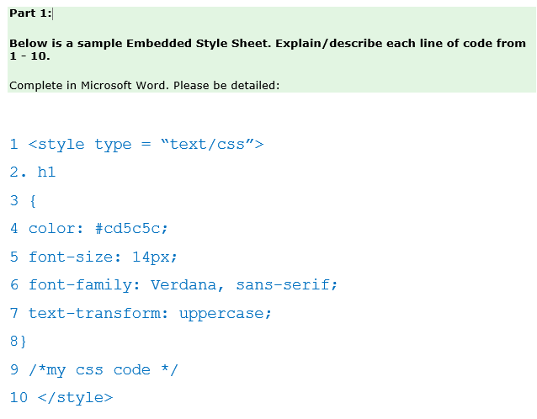

**Assignment 3 Create the following layout with the help of HTML.**

